Error resolving step 1 – logic of scaled data was failing for 0.95. We know that area under spectrum should be conserved. So, checked the difference between area below scaled spectrum and reference spectrum. Error is smaller in the simple scaling code.
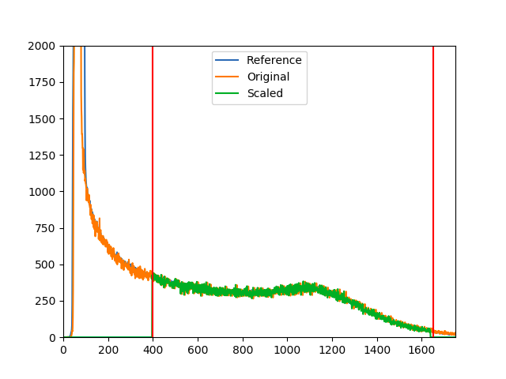
Scaled spectrum from modifed code. The change does not afftect statistical uncertainity.

Error resolving step 2 – Modified idxmask2 assignment to false – earlier size of array was saaumed wrong. No effect on result.
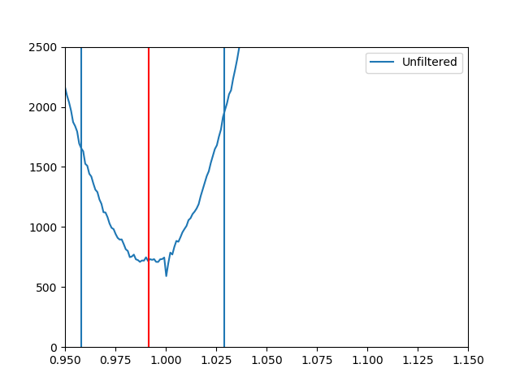
Error resolving step 3 – Strange error – when Polynomial.polynomial was written after numpy
in polynomial fit followin graph was obtained.
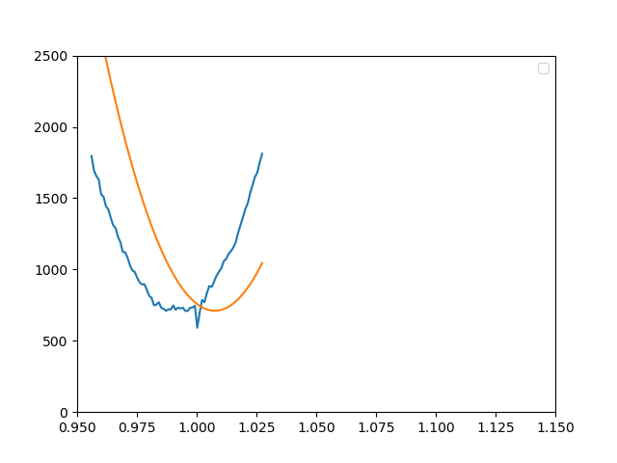
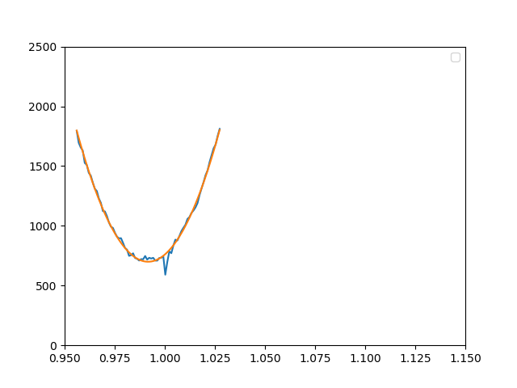
When polynomial.polynomial was removed and no.fit was used, this was resolved. No effect on results.

Error resolving step 3 – Modified calculation of 1 sigma – Earlier confidence line was fitted using all the data between leftbound and rightbound. So, the confidence line was not passing through the endpoints.
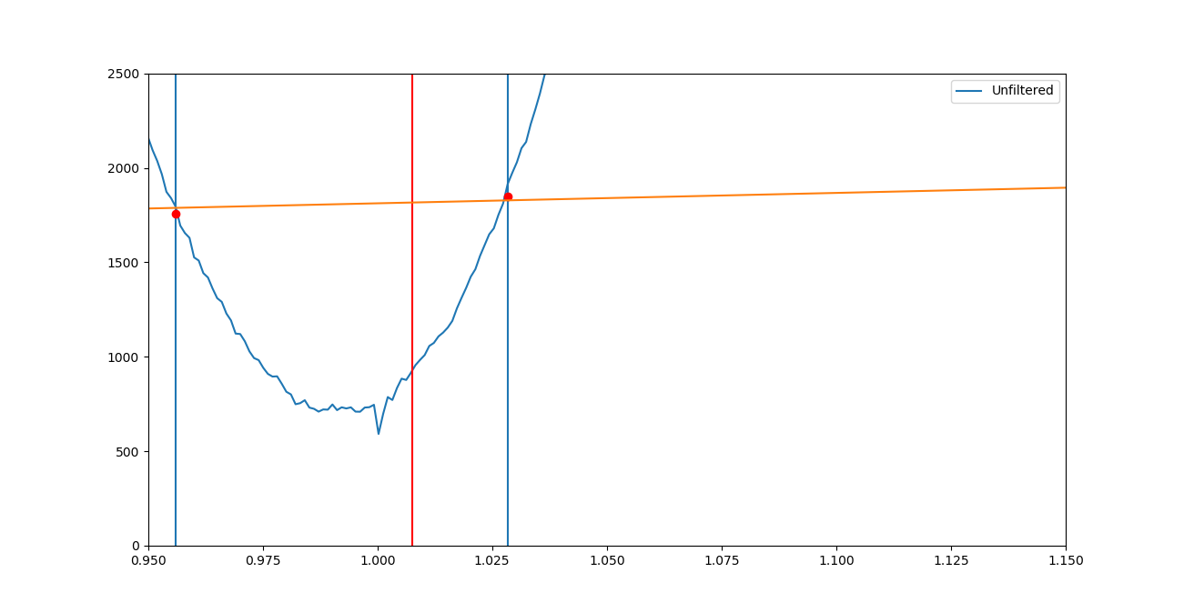
Instead of that I modified the polyfit to fit the line using endpoints only. No noticable impact on results.
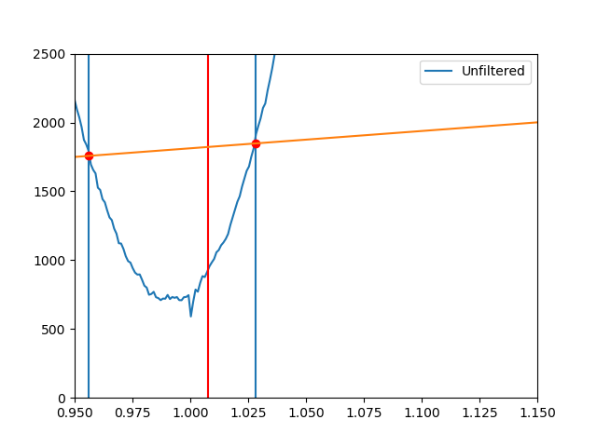
Error resolving step 4 – Earlier while finding mean statistical uncertainity and standard deviation, first reading was left out. After modification mean was not affected much but standard deviation changed due to which systematic uncertainty reduced.

Error resolving step 5 – Earlier the standard deviation formula in code was incorrect. After correcting it, uncertainity in statistical uncertainity has increased but systematic uncertainity has not been affected much.

Error resolving step 6 – Earlier, there was an error in formula of loglikelihood for systematic uncertainity. After correcting it, systematic uncertainity has reached to 8.32%.

Error resolving step 6 – Earlier, the calculation of offset was wrong. After correction, the result is not affected much.

